TEMENOS APPLICATION MANAGEMENT SERVICES

Functional Specification Document
TRADE BANK OF IRAQ
WS04– CHEAQUE COLLECTION

Amendment History

Version | Date | Author / Changed By | Status | Change Description
0.1 | 28/03/2023 | Zia Uz Zahideen | Initial Draft

Sign-off (FSD)

Contact Person | Role / Organization | Date | Signature

FSD Complexity

High

FSD Quality – Client Rating on Understandability
Excellent | Good | Needs Improvement

Table of Contents
1.Background 6
1.1 Introduction 6
1.2 Reference Documents 6
1.3 Glossary 6
2. Requirement Description 7
4. Process Review and Gaps Analysis 17
5. Outward Local Cheques clearing…………………………………………………………………………………….18

Document Updation guidelines:
- Each FSD shall be a stand alone document complete in its description of scope and functionalities covered under BPR.
- Any change requests (post Sign Off of FSD) and approved to be catered within the current functionality, will be managed as an Addendum to the existing FSD.
- Any additional requirements or changes to existing functionalities highlighted in subsequents will be catered for under new FSDs as Change Requests within the respective MVP.

Background

Introduction
The requirements catered for in this FSD are with a focus on the scope for TBI which includes Retail Banking Cheque Collections.
The document covers capturing of Term Deposits and amendments information as per Bank requirement including upload and saving of associated documents (where applicable).

Reference Documents
Document Name | BPR Document
BPR- Cheques For Collections

Glossary
This section provides glossary & descriptions that are used in this document.
Abbreviation | Description

Requirement Description
The following is a summary of the identified gaps and their respective categorization:
WS Process ID | Gap ID | Requirement Description
WS04-06-2 (Deposit Local Outward Cheques Clearing) | WS04-06 01-0001 | To add the amount field (amount) for a cheque that is added to that screen - The user should book every cheque in Cheque collection  Gap Category (Reg | Bnk Rqmt | AE MB): Bank Requirement  Gap Type (Config | Custom | Param): Customization
WS04-06-3 (Cheque Collection) | WS04-06  01-0002 | New version is to be created for Cheque return marking with Reason of return  Gap Category (Reg | Bnk Rqmt | AE MB): Bank Requirement  Gap Type (Config | Custom | Param): Customization
WS09-AD-01  (Premature Encashment) | WS04A06  01-0003 | New ADHOC Charges recovery version created to book the Return Charges if bank want to charge in version PL is fixed and not changeable amount shown as defined against commission type but changeable  Gap Category (Reg | Bnk Rqmt | AE MB): Bank Requirement  Gap Type (Config | Custom | Param): Customization

Process Review and Gaps Analysis
Gap ID | Gap Description |  | Gap Solution
WS04-06 01-0001 | To add the amount field (amount) for a cheque that is added to that screen - The user should book every cheque in Cheque collection |  | Cheque No.1 field will be updated without multi value fields in version TELLER,TBI.INDIR.CHQ.CLG so that User will book evey cheque in cheque collection and remove returned Cheque QUERY CHEQUE.COLLECTION drop down selction as shown in screen shot.
WS04-06 01-0001 | 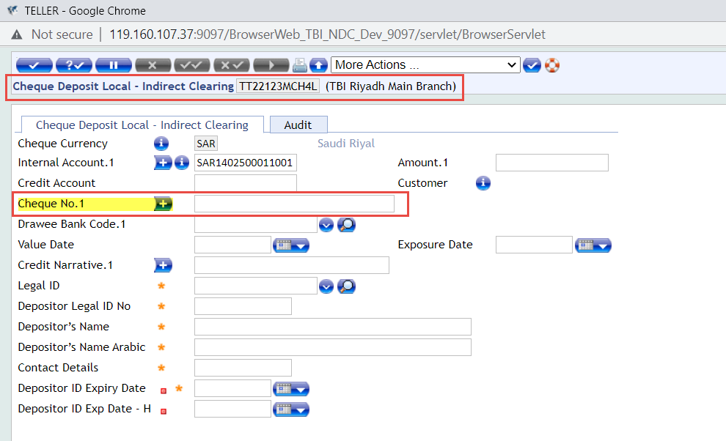  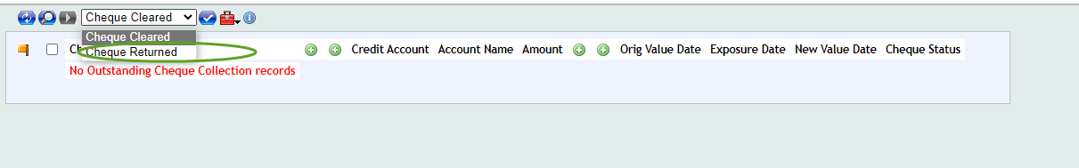
WS04-06 01-0001 | Gap Category: Bank Requirement |  | Gap Type: Customization
WS04-06  01-0002 |  | New version is to be created for Cheque return marking with Reason of return. |  | A new version will be created along with the updated reason for Returned Cheques as shown in the mentioned Model Bank Screen Shot.
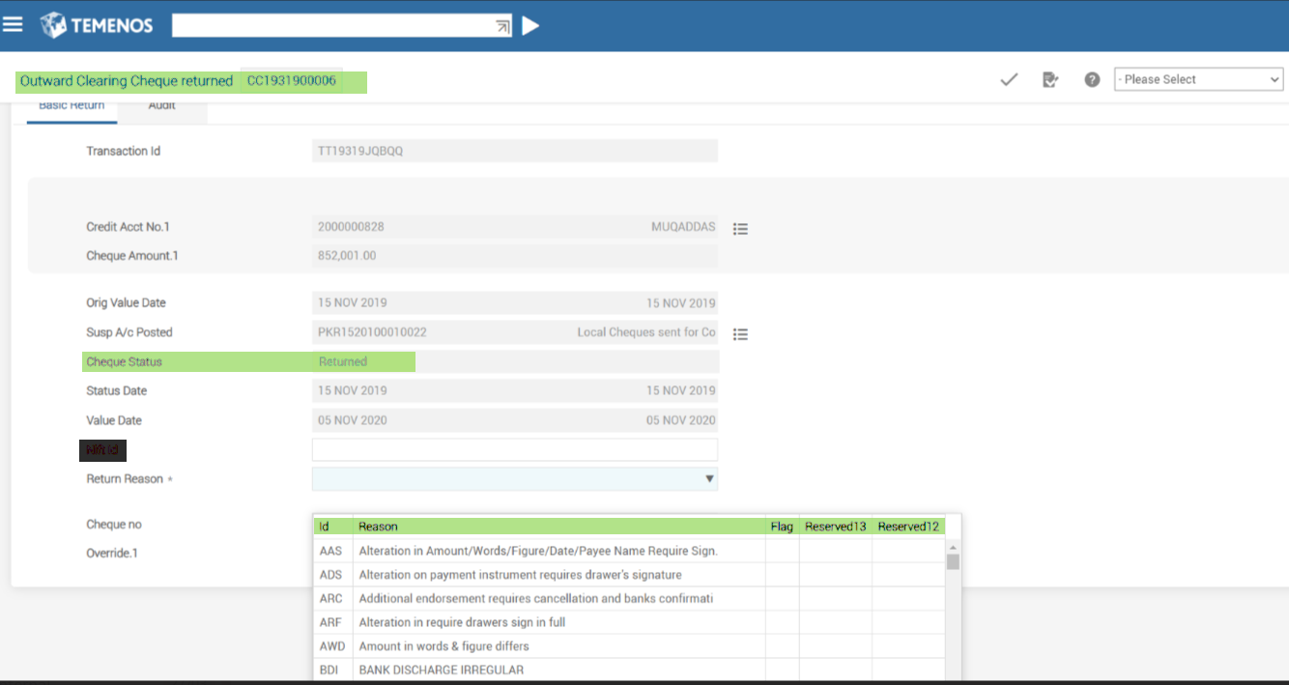
CODE NO. REASON FOR RETURN
1 Funds insufficient
2 Exceeds arrangement
3 Effects not cleared, present again.
4 Reference to Drawer
5 Refer to drawer
6 Kindly contact Drawer/Drawee Bank and please present again.
7 Drawer's signature incomplete
8 Drawer's signature illegible
9 Drawer's signature differs
10 Drawer's signature required
11 Drawer's signature not as per mandate
12 Drawer's signature to operate account not received
13 Drawer's authority to operate account not received
14 Alteration requires drawer's authentication
15 Payment stopped by drawer
16 Payment stopped by attachment order
17 Payment stopped by court order
18 Withdrawal stopped owing to death of account holder
19 Withdrawal stopped owing to lunacy of account holder
20 Withdrawal stopped owing to insolvency of account holder
21 Instrument post dated
22 Instrument out dated/stale
23 Instrument undated/ without proper date
24 Instrument mutilated; requires Bank's guarantee
25 Cheque irregularly drawn/ amount in words and figures differs
26 Clearing House stamp/ date required
27 Wrongly delivered/ Not drawn on us
28 Present in proper zone
29 Instrument contains extraneous matter
30 Image not clear, present again with paper
31 Present with document
32 Item listed twice
33 Paper not received
34 Account closed
35 Account transferred to another branch
36 No such account
37 Title of account wrong/ incomplete
38 Account blocked (situation covered in 21-25)
39 Crossed to two banks
40 Crossing stamp not cancelled
41 Clearing stamp not cancelled
42 Instrument specially crossed to another bank
43 Amount in protective crossing incorrect
44 Amount in protective crossing required/illegible
45 Payee's endorsement required
46 Payee's endorsement irregular / requires collecting bank's confirmation
47 Endorsement by mark/ thumb impression requires attestation by Magistrate with seal
48 Advice not received
49 Amount / Name differs on advice
50 Drawee bank's fund with sponsor bank insufficient
51 Payee's separate discharge to bank required
52 Not payable till 1st proximo
53 Pay order/ cheque requires counter signature
54 Required information not legible/ correct
55 Bank's certificate ambiguous/ incomplete/ required
56 Draft lost by issuing office/ confirmation required from issuing office
57 Bank/Branch blocked
58 Digital Certificate Validation failure
59 Other reasons-connectivity failure
60 Alterations on instrument- Other than "Date" field (Alteration/correction on instruments
are prohibited under Cheque Truncation System. Return reason code applicable to
instruments presented in CTS)
61 Fake/Forged/Stolen-draft/cheque/cash order/interest warrant/dividend warrant
62 ‘Payee's a/c credited'- Stamp required
63 Other reasons (Please specify)
64 Bank Excluded.
WS04-06  01-0003 |  | New ADHOC Charges recovery version created to book the Return Charges if bank want to charge in version PL is fixed and not changeable amount shown as defined against commission type but changeable. |  | New Adhoc Charges Recovery version will be created in which charge code and charge currency will remain non inputtable fields and charge amount will be inputable field as mentioned in the mentioned below screenshot.
 |  | 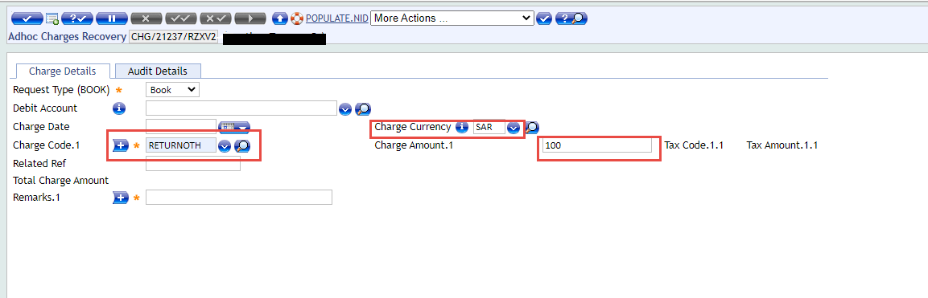

Outward Local Cheques Clearing
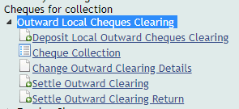

Deposit Local Outward Cheques Clearing
This function is used to deposit local outward cheques for clearing, user needs to fill all the mandatory fields, in addition to credit account, amount, Cheque number and drawee bank, then validate and commit the transaction.

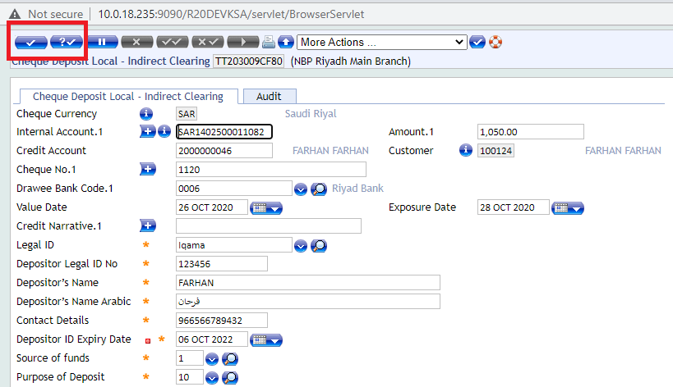

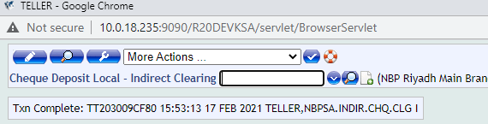
The authorizer should authorize this transaction.
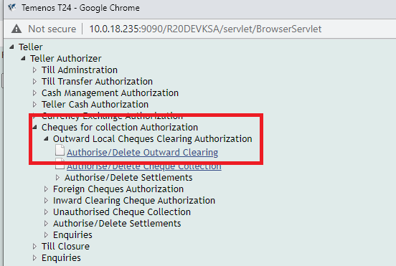

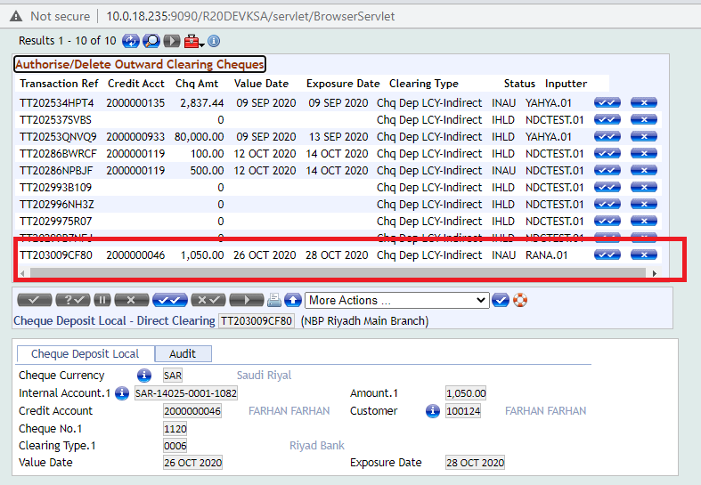

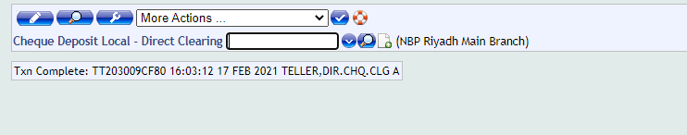

4.1.2 Cheques Collection
Next step after depositing an outward Cheque collection is to mark this cheque as cleared or returned.
If the Cheque is cleared, user need to mark it as cleared.

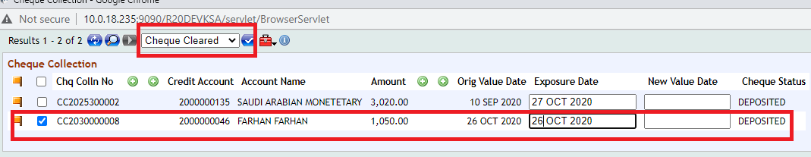
User will get the below message
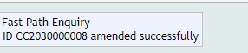
Then user needs to authorize it.

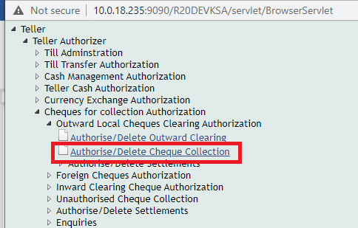

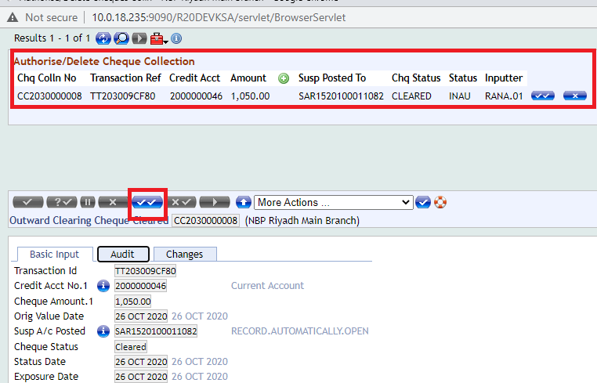

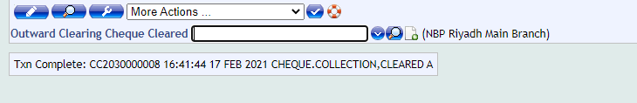
And if the Cheque is returned, user needs to mark it as returned.
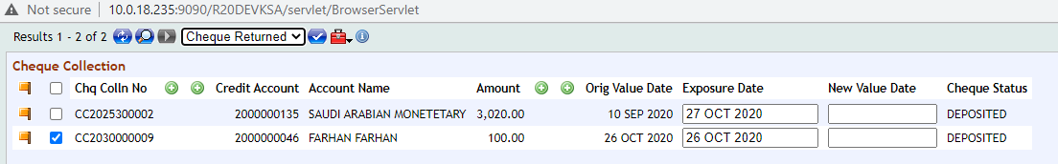

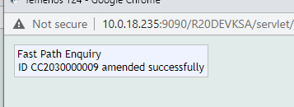
This transaction should be authorized.

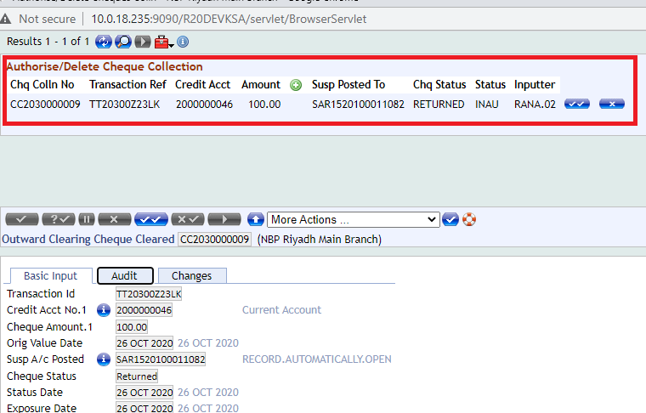

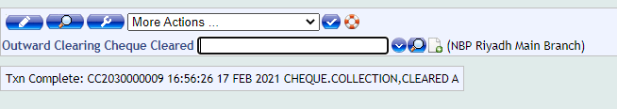

4.1.3 Settle Outward Clearing
This function is used for settlement transaction where user will perform that transaction when Cheque deposited transaction is cleared. During below transaction Sama Clearing account will be Debit & settlement account will be credit
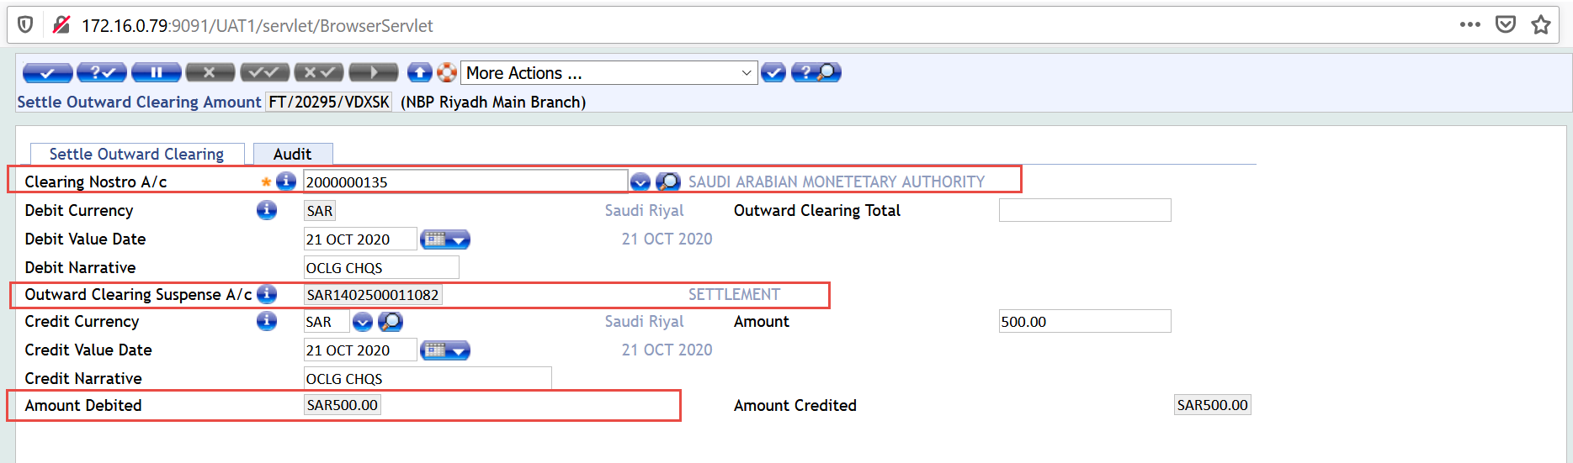

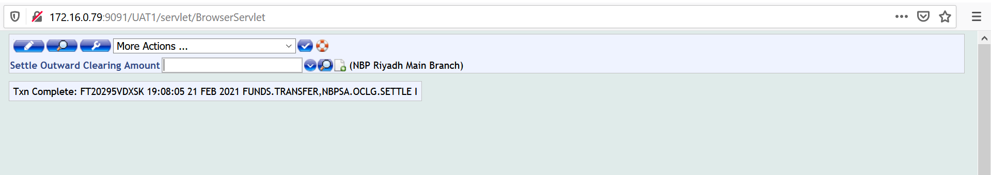
For Authorization.
Teller>Teller Authorizer>Cheques for collection Authorization>Authorize/Delete Settlements
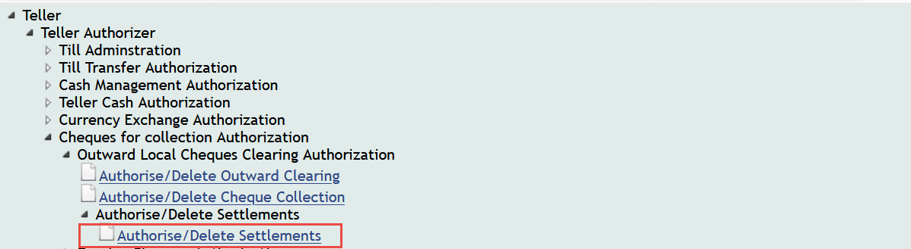
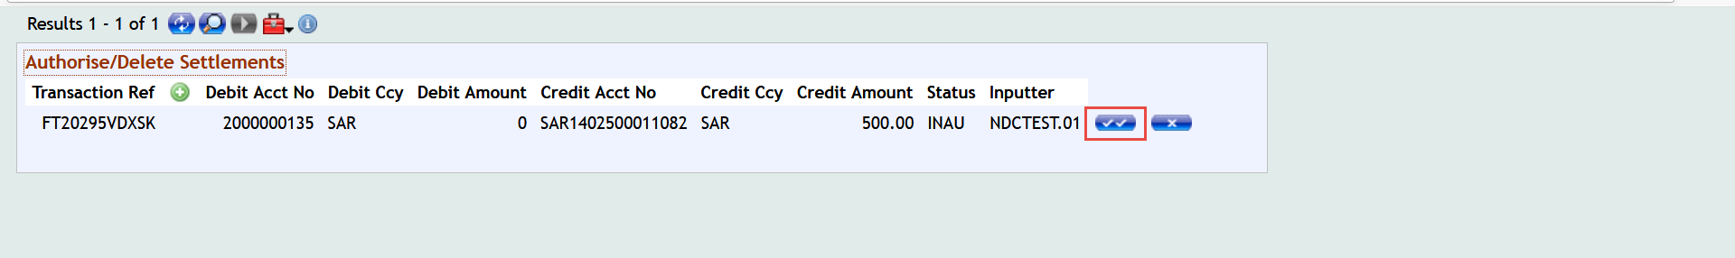
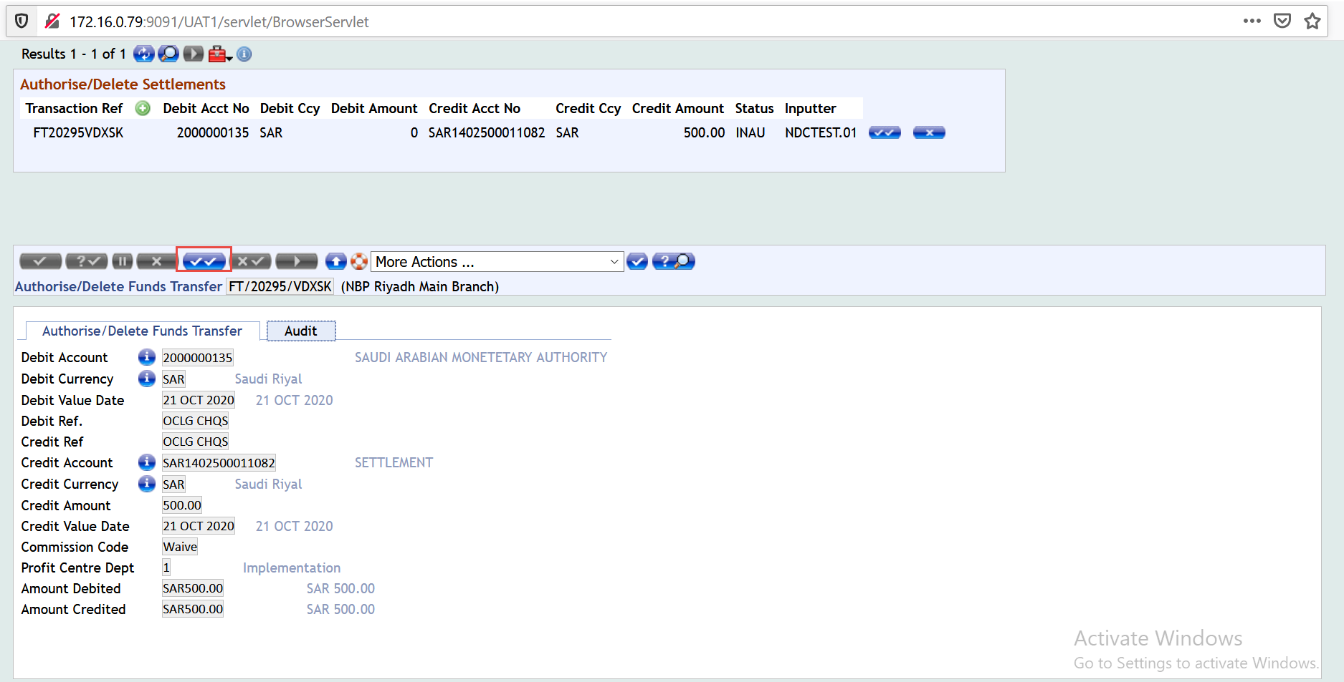

4.1.4 Settle Outward Clearing Return
In case of return Cheques than below transaction will be post for settlement entry
Teller> Cheques for Collection>Settle Outward Clearing Return
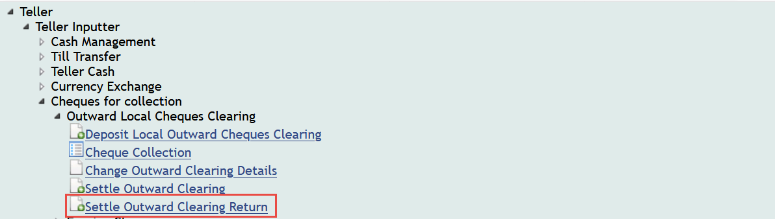
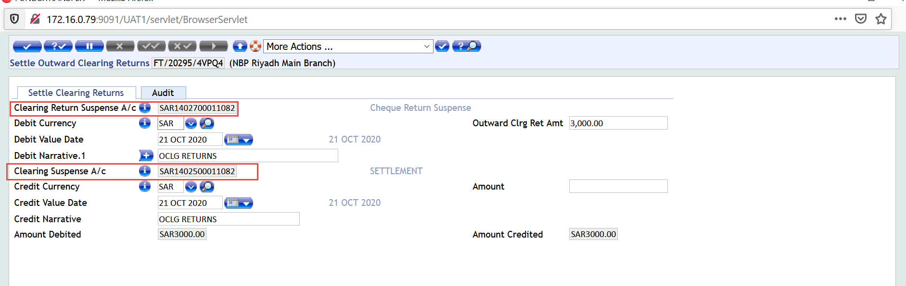

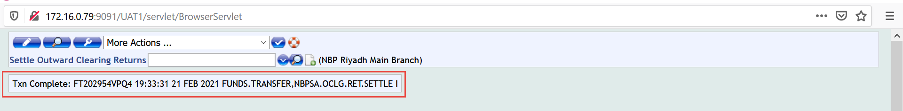
For Authorization
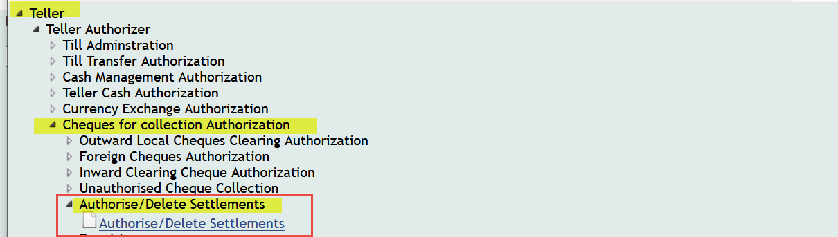
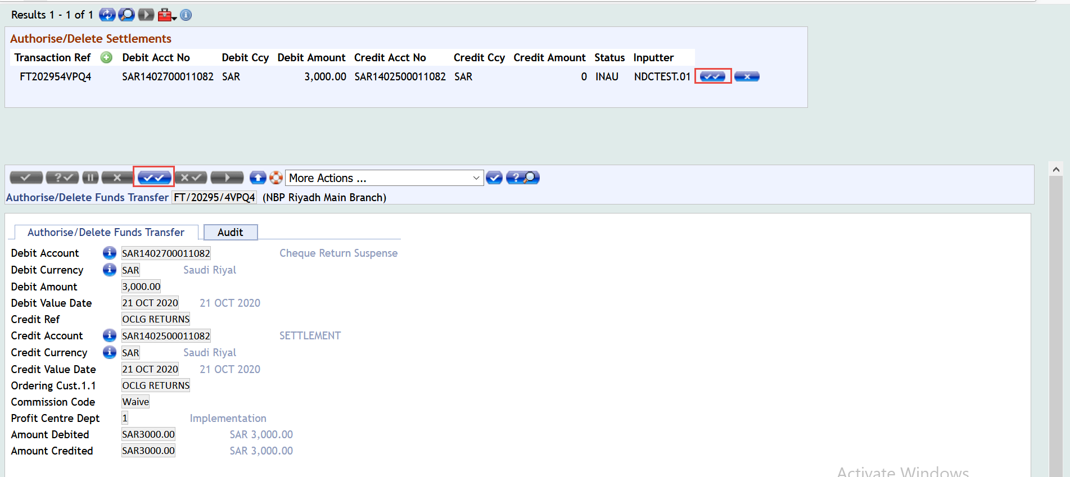
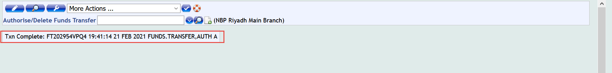

Inward Clearing Cheque

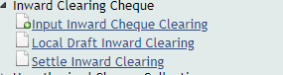

4.1.6 Input Inward Cheque Clearing
This function is used to input inward cheques for clearing, user needs to fill the fields of debit account, debit amount, debit Cheque number, Cheque date and ordering bank.1, after that user needs to validate and commit the transaction.

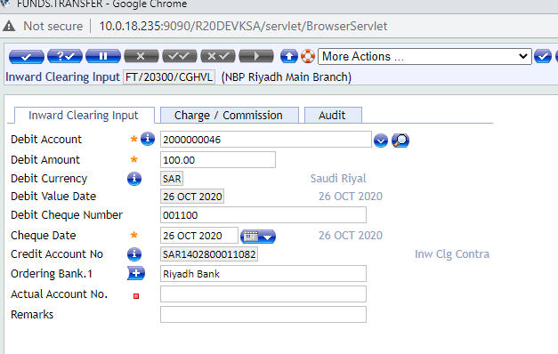
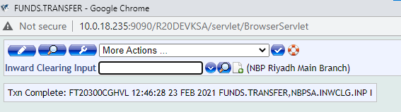
For authorization
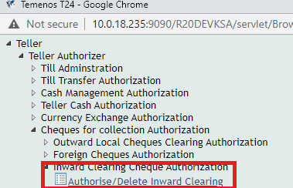

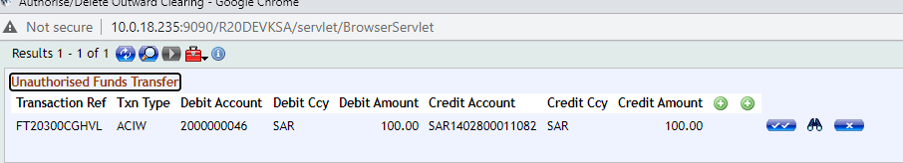

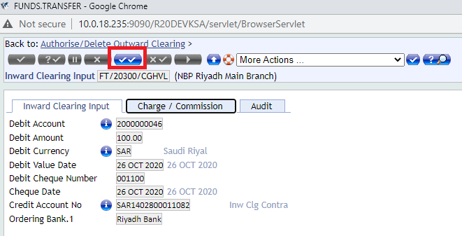

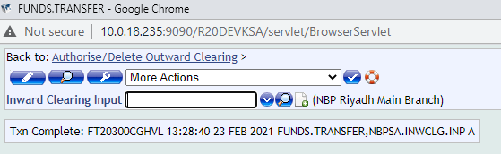
After authorization, the transaction will be completed.

4.1.7 Local Draft Inward Clearing
This function is used to pay local draft cheques through Inward clearing.
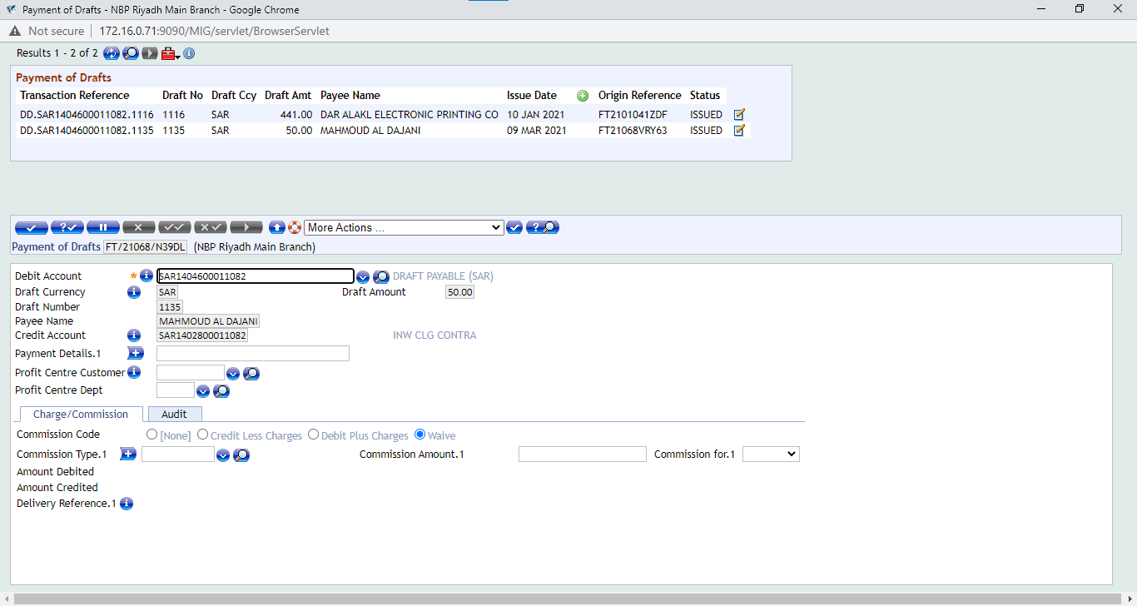

User needs to validate & commit the transaction.
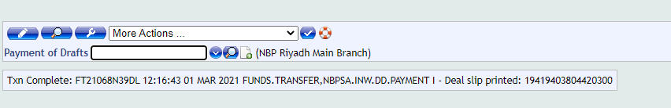
For authorization
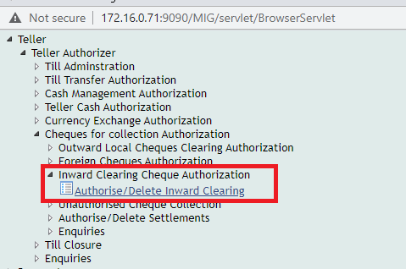
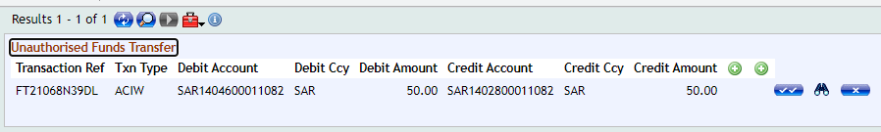

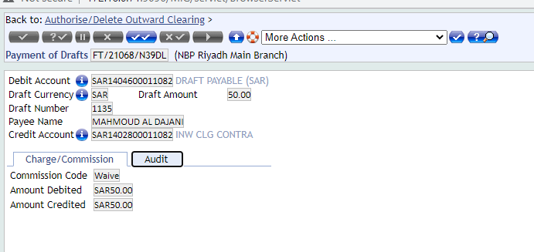

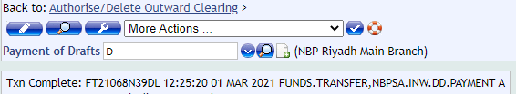
The transaction is completed then user needs to settle this transaction.

4.1.8 Settle Inward Clearing
This function is used to settle inward clearing cheques either draft or cheques that are from the customer chequebook.
User needs to input Clearing Nostro A/c
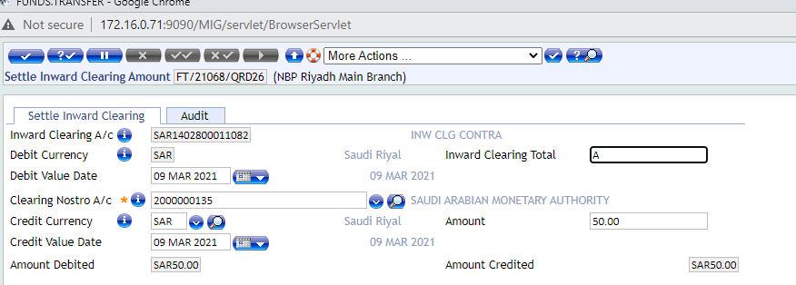
Then validate & commit the transaction.
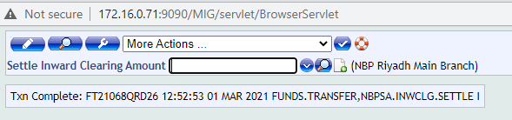
For authorization
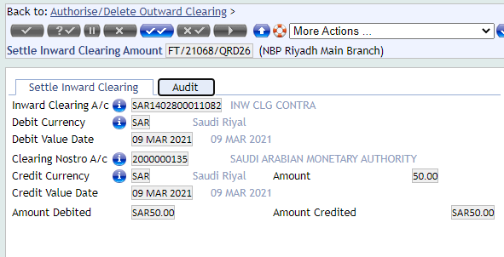

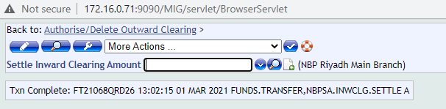

4.1.8 Unauthorized Cheque Collection
This function shows all of the unauthorized cheques for collection.
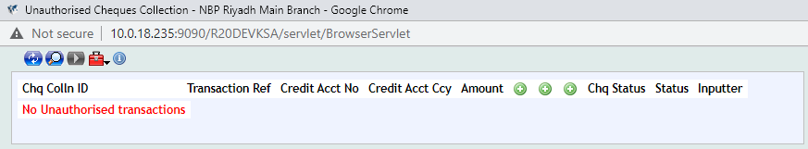

Enquiries

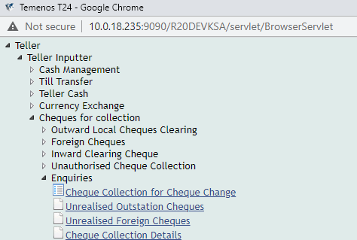

4.1.10 Cheque Collection for Cheque Change
This function is used to check the status of the cheques either its inward or outward clearing
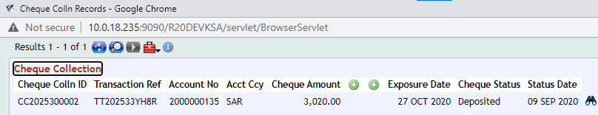

4.1.11 Cheque Collection Details
This function is used to check the details of every cheque in clearing.
